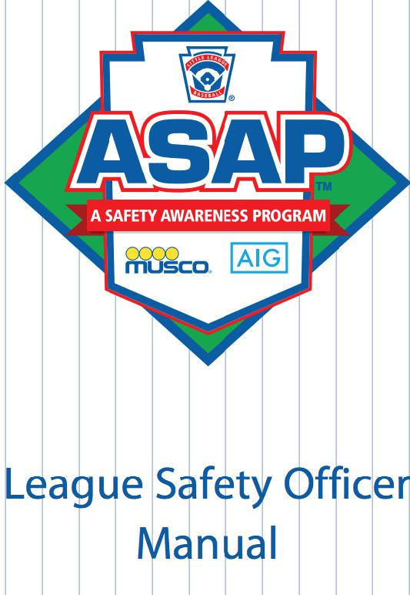
League Name: Danvers National Little League
League Number: 2211505
TABLE OF CONTENTS PAGE(S)

Danvers National Little League Safety Mission Statement 3
2023 DNLL Officials, Emergency Phone Numbers & Registration Data 4
DNLL Code of Conduct 5-6
DNLL Standards of Participation (For Coaches) 7-10
2023 Little League Volunteer Application 11
Player / Coach Development & Fundamentals Training 12-17
Basic First Aid 18-22
Medical and Injury Reports & Forms 23-30
Snack Bar Management & Safety Plan 31-32
Equipment Inspection & Replacement Policy 33
DNLL Pre-Game/Practice Equipment & Field Inspection Form 34
2023 Annual Little League Facility Survey 35-38
Inclement Weather Policy 39-40
Parents Guide to Child Protection 41-42
DNLL Parking Policy & Tractor Safety 43

Copies of the Safety Manual are distributed to the Board of Directors at the January Monthly Meeting and all Managers on draft day. Additional copies are available in the Snack Bar.

Danvers National Little League

Mission Statement

“The mission of Danvers National Little League is to honor the game by providing a structured and supportive league environment to develop in our players the qualities of sportsmanship, discipline, teamwork, and a life-long appreciation of baseball.”

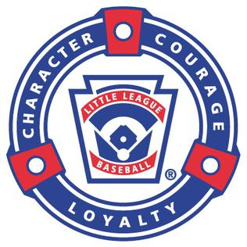

2022 Danvers National Little League Board of Directors
Position | Name | Phone
Officers
President | Mike Hanlon | (617) 470-7548
Vice President | Karen Devaney | (617) 947-4215
Secretary | Kevin Koufos | (978) 210-8272
Treasurer | Dave Gotts | (617) 680-8850
Safety Officer | Jarod Waterman | (978) 809-9623
Player Agent | Nat Arlander | (978) 766-5832
Directors
Player & Coach Development Chair | Mike Moroney | (978) 360-8852
Umpire in Chief | Greg Tremblay | (617) 504-5620
Major Director | Greg Tremblay | (617) 504-5620
AAA Director | Paul Willis | (781) 883-4753
Minor Director | Ted Blake | (703) 862-2545
Farm Director | Dan Kilbride | (978) 853-8189
T-Ball Director | open
Equipment Chairperson | Paul Willis | (781) 883-4753
Fundrasing Chairperson | Jess Burrell | (978) 210-3917
Building and Grounds | Mark Smith | (781) 983-6750
D | DdD
Emergency Telephone Numbers
Lyons Ambulance: | (978) 774-1500
Police: | (978) 774-1212
Fire: | (978) 774-2424
Beverly Hospital: | (978) 922-3000
Poison Control: | (800) 682-9211
DNLL Player Registration Data
Player roster data and Manager/Coach data is submitted
via the Little League Data Center.

Danvers National Little League Code of Conduct
Baseball, by the very nature of the game, is a very physical and competitive sport. It is sometimes inevitable that tempers will flare and poor judgment will occur. As parents and coaches, it is our responsibility to encourage our children and players to play by the rules. We must remember, however, that children learn best by example. We must applaud the good plays from both teams and avoid yelling at players, coaches, officials, or spectators. Positive attitudes displayed by all will benefit everyone involved.
Danvers National Little League, in an effort to address any unfortunate displays of poor judgement, has determined that the following guidelines must be followed. Disciplinary action will be taken in the event that, during any sanctioned Danvers National Little League event, any manager, coach, parent, or official displays unsportsmanlike conduct unbecoming to himself and/or Danvers National Little League.
1 Abuse or harassment of an official, coach, player, or spectator, whether it be verbal or physical, including but not limited to, swearing and/or obscene gestures which are reported to Danvers National Little League will not be tolerated.
2 There are to be no issues raised with an official during the course of an inning in play.
3 Only the Team Manager may initiate a discussion with an official. Any discussion with officials must occur between innings or following the game. This discussion will be in the presence of the opposing manager and official.
4 If there is a question on a specific call, the Manager may, from the dugout or Third Base Coaching position, ask the umpire to explain the call. Even if an appeal is made, once explanation from the official is received, further discussion must wait until in between innings.
5 All questions and discussions held with umpires, managers, coaches, or parents will be held in conversational tones only.
6 If a parent, spectator, or coach is disruptive or demonstrates unsportsmanlike conduct, the umpire or league officials may ask the parent, spectator, or coach, to leave the ballpark. Following such occurrence, the President and Umpire in Chief will be notified of this violation.
In the event the League is notified of a violation of the above guidelines, an investigation will occur. Following the investigation of the facts, a determination will be made by the President and Umpire in Chief. The penalty for a first violation of the above procedures will be a warning. Subsequent violations could result in a minimum of one week suspension up to, and including, expulsion from the program for the remainder of the season. In the event the President and Umpire in Chief deem the circumstances more severe, and requiring further action, a vote of the Board of Directors will be taken and discipline imposed.
Any issues/concerns regarding the actions of a specific official should be brought to the attention of the Umpire in Chief and the President. They will discuss the situation and decide whether further action must be taken. In the event the investigation of the facts concludes disciplinary action is necessary, the above procedures will be followed. Any aggrieved coach, manager, parent, or official, who has received a suspension of more than one week, can petition, in writing, for an appeal within three days of the suspension. A hearing with the Board of Directors, including the Umpire in Chief, will be scheduled as quickly as possible.

Danvers National Little League Code of Conduct
An appeal hearing, which will include the aggrieved party, other parties involved as deemed appropriate by the President, and the Board of Directors, will be held, and the decision rendered, within one week of the written appeal request.
It is not the intention of Danvers National Little League to limit the growth or development of any player, coach, or official within our program. It is with this in mind that we feel firm guidelines, on which our managers, coaches, officials, players and parents can rely, will encourage an attitude of good sportsmanship and mutual respect that will serve them well in this area and other areas of their lives.
Let’s encourage the positive in youth sport. Applaud good efforts in both victory and defeat. Let’s work toward removing the physical and verbal abuse present in youth sport. Communicate positively and provide support – keeping the game fun. Let us work together to make sure that this firm set of guidelines is just that. With all of your help these disciplinary actions will never need to be imposed.
THE DANVERS NATIONAL LITTLE LEAGUE BOARD OF DIRECTORS
I have read, and understand, the Danvers National Little League Code of Conduct.
Signature of Parent, Manager, Coach or Official
Date _____/_____/_____

DNLL STANDARDS OF PARTICIPATION

- Application for Eligibility to Participate

Any individual who desires to participate in the Danvers National Little League shall, prior to the start of each new season, and at a time designated by the President, submit an application for eligibility to participate in the Danvers National Little League. The form of application and the information requested thereon shall be determined by the President. The applicant shall be required to authorize the Danvers National Little League, and/or the District to which it belongs, access the Criminal Offender Record Information (CORI) by executing the form attached hereto as such or other form as selected by the President. The applicant shall also be required to authorize Danvers National Little League and/or the District to which it belongs access to the Sex Offender Information by executing the form attached hereto or such form as selected by the President. All Officers, Members of Boards, Managers, Coaches, Umpires, Concession Workers, Instructors, and Staff who have attained the age of 18 by the time of the first registration for a given season must submit an application for eligibility to participate. The application must be submitted on an annual basis and at the time set forth above.

- Accessing Criminal Offender Record Information and/or Sex Offender Information

The President and/or Safety Officer shall access Criminal Offender Record Information for all applicants. The President and/or Safety Officer may access at his/her discretion, Sex Offender Information, for all applicants or may elect to authorize the District to perform such function on his/her behalf.

- Initial Screening

The President and/or Safety Officer shall have access to Criminal Offender Record Information. The President and/or Safety Officer shall review the Criminal Offender Record Information relative to each applicant and may at his/her discretion, disqualify any applicant from participation in the Danvers National Little League on any of the following grounds:
- The applicant has failed to provide a completed application for eligibility to participate in the Danvers National Little League.
- The applicant has failed to authorize the Danvers National Little League access to Criminal Offender Record Information or Sex Offender Information; or
- The applicant has been convicted of any crime of violence against minors, or any crime which indicates that the applicant may pose a risk to the safety and well-being of children, including, but not limited to:
- Indecent assault and battery on a child under fourteen;
- Indecent assault and battery on a mentally retarded person;
- Indecent assault and battery on a person who has obtained the age of fourteen;
- Rape;
- Rape of a child under sixteen with force;
- Rape and abuse of a child under the provisions of MGLA,Chapter 265,
Section 23;
- Assault with intent to commit rape;
- Assault of a child under sixteen with intent to commit rape;
- Kidnapping of a child under the age of sixteen;
- Open and gross lewdness and lascivious behavior;
- Unnatural and lascivious acts with a child under sixteen;
- Distribution and trafficking of narcotics or other controlled substances;
- Possession of a narcotic or controlled substance with intent to sell;
- Possession of a narcotic or controlled substance;
- Driving under the influence (within 6 years); or
- Intent to commit any of the above crimes; or
- The applicant has been held liable for civil penalties or damages involving sexual or physical abuse of children; or
- The applicant has had his/her/her parental rights terminated for reasons involving sexual or physical abuse of children; or
- The applicant is subject to any court order involving sexual abuse or physical abuse of a minor; or
- The applicant has a history, as verified by the President, with any other organization (volunteer, employment, etc) of complaints of physical or sexual abuse of minors or has resigned, been terminated or been asked to resign from a position, whether paid or unpaid, due to complaint(s) of physical or sexual abuse of minors.

- Notification of Disqualification

The President shall notify any applicant, in writing, of any decision to disqualify the applicant from participation in the Danvers National Little League. The notification shall be mailed, via certified and regular mail, to the address furnished by the applicant on his/her/her application. The notice shall advise the applicant that he/she has a right to appeal the President’s decision. A photocopy of Section E herein, entitled "Appeal of Initial Screening Decision" shall be attached to the notice. The notice shall set forth the President’s name and current mailing address.

- Appeal of Initial Screening Decision

Any applicant may appeal the President’s initial screening decision by requesting an appeal. The applicant’s written request must be mailed to the President, at the address set forth in the notice, within 14 days of the applicant’s receipt of notice. The applicant may set forth the reasons in support of his/her/her appeal, but is not required to do so. The President, upon receipt of the request for appeal, shall schedule a hearing of the appeal at a time and place designated by the President but no later than 30 days from the date when the request for appeal is received by the President. The special meeting shall not be announced nor opened to the general public.

The appeal shall be heard by a three member panel consisting of the following individuals:
- Executive Vice President
- Secretary
- Treasurer

In the event that any of the above is unable or unwilling to participate in hearing the appeal he/she then shall so notify the President who shall replace that individual with the next willing participant in the following order of succession:

- Player agent
- President
- Safety Officer
- Umpire in Chief
- Major League Director
- AAA League Director
- Minor League Director
- Farm League Director
- T-Ball Director
- Building and Grounds Chairperson
- Equipment Chairperson
- Fund Raising Chairperson
- Coach-Player Development Chairperson
- Player Evaluation Chairperson

The applicant may present any evidence he/she desires to the Board of Directors. The applicant must be willing to start his/her presentation by sharing with the Board of Directors his/her recollection of his/her record of criminal offenses. The applicant may review any CORI information in the possession of the President.

In the event the applicant states a history of convictions that differs with the CORI information received by the President, then the President, who shall be in attendance at the hearing of all appeals, shall represent that such a discrepancy exists and the appeal shall be denied.
The applicant shall be successful in his/her appeal only in the event that a majority of the board votes in his/her favor, in which event, the applicant shall be deemed eligible for participation in the Danvers National Little League. The board must notify the applicant in writing of its decision within 10 days of the date of hearing the appeal.
- Reconsideration
The President may reconsider any application for eligibility to participate at any time, even after having approved of same upon initial screening, but only in the event that new information becomes available relative to whether the applicant poses a risk to the safety and well-being of the children. Initial Screening of President
The immediate past President, if CORI certified, shall make the initial screening decision relative to the application submitted by the President.
Amendment
The Board of Directors may amend this standard at its discretion and in accordance with its established procedure for acting as a governing body as set forth in the by-laws.

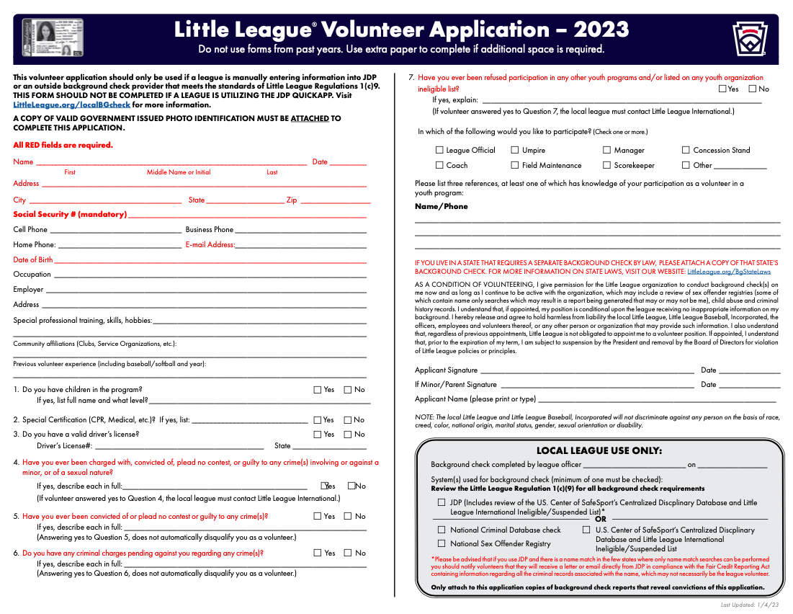
.

Player / Coach Development and Fundamentals Training

Each season DNLL strives to offer a structured baseball program for all players through the Winter Evaluation Program, Coaching Clinics, Coaching Materials, Batting Cage Facility and Stan Brown Jamboree.

Winter Workouts Program

The Danvers National Little League baseball season kicks off on Friday, January 6th with its Winter Workouts Program at Extra-Innings (Middleton).
The 12-week program is directed by DNLL Player & Coach Development Director, Mike Moroney and assisted by Extra Innings Staff, qualified DNLL volunteers and DNLL AlumniThe program runs every Friday night from January 6th — March 31th from 6 PM to 9:30 PM. The program is structured into the following three sessions:
- 6 PM — 7 PM for Little League Age 7 and under;
- 7 PM — 8 PM for Little League Age 8, 9 and 10 year olds;
- 8 PM — 9:30 PM for Little League Age 10, 11 and 12 year olds.
Times are flexible, and 100 players are projected to attend.
The program is carefully planned and organized. On Thursday, December 8th from 6:30 PM — 7:30 PM, DNLL Player & Coach Development Director hosts a Coaching Clinic at Extra-Innings (Middleton) for all DNLL Managers and Coaches. This Coaching Clinic serves as a planning session for the Winter Evaluation program, and best practices are reviewed. More specifically, all DNLL Managers and Coaches are taught to instruct a dynamic warm-up routine (See Attachment #1) as well as proper hitting, throwing, fielding drills and techniques.

Coaching Clinics

This clinic is sponsored by District 15, and is anticipated to be held on Saturday, March 25, 2023 from 9 AM — 1 PM. At this clinic, DNLL Managers and Coaches learn how to teach the fundamental skills of the game and plan fun and effective practices.

Coach Materials

Each year coaching aids and materials are budgeted for, purchased by the league and distributed to all Managers at each division within the DNLL program.
This practice allows DNLL to maintain a consistent method of instructing the players as they progress through the program. Coach materials can be accessed from the DNLL website (www.danversnats.com) and include: "Teaching for Tomorrow" (by Al Herback), bigalbaseball.com, positivecoach.org and coachdeck.com.
(See Attachment #2)

DNLL Batting Cage/Practice Facility

In 2011 Danvers National Little League constructed a Batting Cage/Practice Facility at Tapley Park. The facility consists of one batting cage tunnel, four soft toss nets and two portable pitching mounds. The facility is supervised by qualified DNLL volunteers and operates from 9 AM — 8 PM Monday through Saturday and from 12 PM — 8 PM on Sundays. Teams are assigned practice times throughout the preseason, regular season and post-season. (See Attachment # 3 for Batting Cage Rules)

Stan Brown Jamboree

Each year Danvers National Little League extends the Little League Baseball season for its players by hosting the Stan Brown Jamboree (SBJ). SBJ is a festive celebration of Little League Baseball and a tribute to our Founder and former District 15 Administrator - Stan Brown.
The SBJ runs from the end of July to the middle of August, and approximately 50 teams encompassing more than 600 players from District 15 and Boston's North Shore participated — including several Danvers National Little League teams
ATTACHMENT 1:
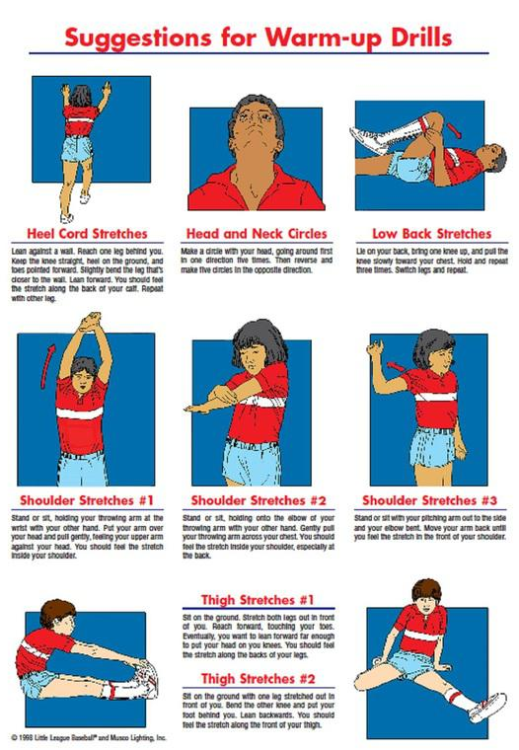

Do not use forms from past years. Use extra paper to complete if additional space is req

2:

The Big Al Way

Big Al was invited on TED TALKS to share his approach to "Coaching with a Commitment to Develop the Player and the Person". This is the same presentation we have done live at the start of every coaching clinic.
We think it is critical that coaches understand how to connect and develop a positive relationship
with every player and person on a typical Little League team; from the 3 Big Al's to the 6 Medium Al's to the
2 Little Al's to the Team Clown down at the end of the bench.

Please take time to watch this video before you meet the players on your new team,and then log on to
access the online coaching resources to get ready for your first practice.

For Coaches | For Parents
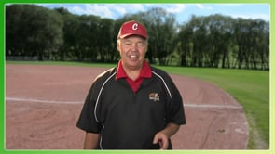
Coaches are provided with all of the tools, curriculum, practice plans, teaching tips, drills and resources they will need to coach a Little League season from start to finish. | Parents and players are provided with the same skills videos and techniques as the coaches plus lots of drills, fun challenges and games they can practice every night at home.

Some of the key principles of the Big Al Way
COACHES |  |  | COACHES AND PARENTS
Coaches need to understand what young players are about at the age level they coach, their attention span, motivations, attitudes, fears, personalities and their skills and abilities.  They need to know the role the parents want to play, how players this age typically respond to adults and what gets them excited and turned on to the game. | Coaches need to put together a season long plan focused on developing every player on their team in practices and games.  Coaches need to set clear expectations for players and their parents share it before the season starts.  And coaches need to learn how to plan and run practices that are well organized dynamic & fun. | They need to build into their plan pre-practice and pre-game routines that provide all players more quality repetitions.  Coaches need to use drills that allow players to practice the skills without fear and then integrate fun challenges so they get to compete in every practice.  This Big Al Way approach runs throughout the T&D center for coaches. | Coaches and parents need to understand the fundamentals and how to the teach skills in an age appropriate way.  They need to be able to identify the common mistakes and learn how to correct them.  The Big Al ‘s “Teach it- Try it-Game it” player development approach will work at the diamond and at home. | Finally, parents need to understand their role and how they can support their son or daughter on game day.  We all know that Game Day is for the players.  It is important that coaches and parents understand the critical role they have in making game day a fun and positive experience for everyone!
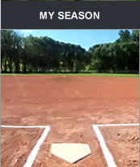 | 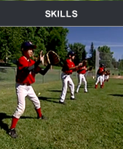 | 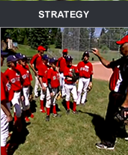 | 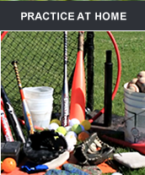 | 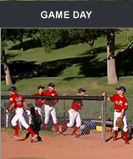
Learn how to fit a glove and select a bat  Helpful tips how to be a team player and work with your coach all season long | The technical breakdown of all of the skills your child needs to develop  The description of the most common mistakes and how to correct them for each skill | Introduction to basic baseball terms, rules and positions for the team  Introducing the roles and responsibilities of each position in several game situations | Drills and fun games and challenges to do at home. The goal is to get quality repetitions, improve your technique and strength and best of all develop a passion for the game | Tips on how to prepare for and have a lot of fun on game day  If you approach game day the right way it can be a lot fun for you and your son or daughter

ATTACHMENT 3:

DANVERS NATIONAL LITTLE LEAGUE
Hours of Operation

Monday - Saturday, 9 AM - 8 PM
Sunday, 12 PM - 8 PM

Batting Cage Rules
- A Qualified DNLL Volunteer must be present in this facility at all times.
- Helmets must we worn.
- No food, drinks, gum or seeds.
- No metal cleats.
- Soft "squish" balls must be used at soft toss stations.
- Promptly retrieve all balls hit outside of this facility.
- Keep this facility clean and return equipment to shed or job box when not in use.

Basic First Aid
Basic First Aid, CPR and Defibrillator training is anticipated to be held as part of the Coaching Clinic at Beverly High School on Saturday March 25, 2023 from 9 AM —1 PM.
DNLL Board of Directors, Managers, Coaches and volunteers are expected to attend. It is DNLL's intention to have all Managers and Coaches trained in Basic First Aid, CPR and Defibrillator use.
Attendance is taken by the DNLL President, and recorded in the April monthly meeting minutes.
Basic First Aid guidelines are outlined in the subsequent sections to provide DNLL volunteers with information in case of an incident or injury occurs at one of our baseball facilities.
First Aid Kits
A new First Aid Kit is issued prior to the start of the regular season within each team's equipment bag, so that a kit is present at all games and practices throughout the season.
In addition to team First Aid Kits, a fully equipped First Aid Kit and supplies to replenish team kits are located in DNLL's Snack Bar at Moulton Field.
Each team will have the minimum following supplies in their First Aid Kit at all times:
- Three to four ice packs
- One roll of gauze
- Fifteen 1"x3" large band-aids
- One pair of scissors
- One roll of tape
- Gauze pads
- Three antiseptic towels/ One tube of antiseptic cream
In the event that First Aid Kit supplies are used up, notify the Safety Officer or visit the Snack Bar to replenish the kit.
Be Prepared When Calling E-911!
In the event of an accident or emergency, please provide the following IMPORTANT information to the E-911 dispatcher:
- Location of accident
- Phone number you are calling from
- Caller's name
- Description of accident
- Number of people injured
- Condition of injury (bleeding, conscious, breathing)
- Is first aid being administered
Continue caring for injured until an ambulance arrives.
Have someone meet ambulance to guide them to the accident scene.
Most Common Types of Injuries
CUTS
- Clean area with soap and warm water, carefully washing away any dirt.
- Apply direct pressure to wound until bleeding stops.
- Apply sterile gauze on wound.
- If cut is deep, get to doctor right away.
ABRASIONS
- Clean area with soap and warm water, carefully washing away any dirt.
- If bleeding or oozing, bandage the abrasion to protect it from infection (see above "CUTS").
FRACTURES
- A simple fracture does not puncture the skin. Without care it could become more serious. •
- Check for swelling around affected area. There may be discoloration of the skin.
- If victim complains of tenderness and pain in the area or says that they felt the break, seek doctor right away.
- Wait for medical help. Avoid moving the victim. Keep the person warm, comfortable and reassured
CARDIAC ARREST
How to Recognize Sudden Cardiac Arrest (SCA)
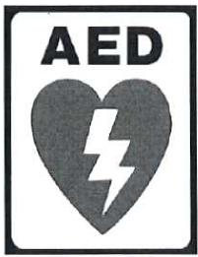
- Person has collapsed and is unresponsive; gasping, gurgling, snorting, moaning or making labored breathing noises.
Other warning signs and symptoms of a heart condition include chest pain, dizziness, shortness of breath and/or passing out (during/after exercise).
- Seizure-like activity is possible.
- Suspect SCA in a collapsed player after a blow to the chest by a baseball or another player.
Action Plan for SCA
- Recognize Sudden Cardiac Arrest.
- Call E-9-1-1.
- Immediately begin cardiopulmonary resuscitation (CPR) and continue until EMS arrives. Push hard, push fast in the center of the chest.
- Retrieve the Automated External Defibrillator (AED) located in the snack bar. Clear the area and use the AED to restore the heart to its normal rhythm.
- Continue CPR and AED use until EMS arrives and can provide advanced cardiac life support, including additional resuscitative measures and transfer to hospital.

CONCUSSIONS AND TRAUMATIC BRAIN INJURY

A concussion is a type of traumatic brain injury, or TBI, cause by a bump, blow, or jolt to the head that can change the way your brain normally works. Concussions can also occur from a fall or blow to the body that causes the head and brain to move quickly back and forth. Health care professionals may describe a concussion as "mild" brain injury because concussions are usually not life threatening. Even so, their effects can be serious.
How to Recognize a Possible Concussion
- A forceful bump, blow or jolt to the head or body that results in rapid movement of the head.
- Any change in the athlete's behavior, thinking or physical functioning
Signs Observed by a Coach in a Player
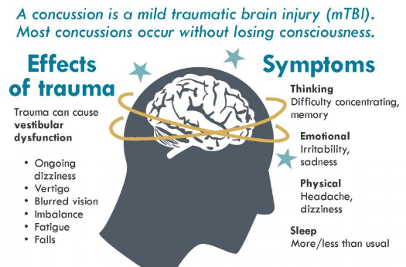
- Appears dazed or stunned
- Is confused about assignment or position
- Forgets an instruction
- Is unsure of game, score, or opponent
- Moves clumsily
- Answers questions slowly
- Loses consciousness (even briefly)
- Shows mood, behavior, or personality change
- Can't recall events prior to hit or fall
- Can't recall events after hit or fall
Symptoms Reported by Athlete
- Headache or "pressure" in head
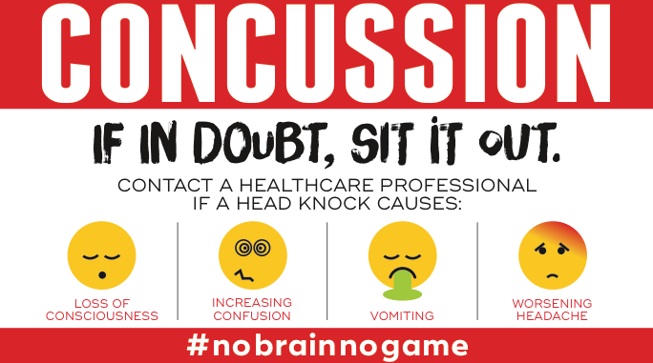
- Nausea or vomiting
- Balance problems or dizziness
- Double or blurry vision
- Sensitivity to light
- Sensitivity to noise
- Feeling sluggish, hazy, foggy, or groggy
- Concentration or memory problems
- Confusion
- Does not "feel right or is "feeling down"

What to do when a Concussion Occurs
- Remove the athlete from play. "When in doubt, sit them out!"
- Ensure that the athlete is evaluated by a health care professional experienced in evaluating for concussion.
- Inform the athlete's parents or guardians about the possible concussion.
- Keep the athlete out of play the day of the injury and until a healthcare professional, experienced in evaluating for a concussion, says the player is symptom free and it is ok to return to play.

HEAT ILLNESS

Heat exposure can lead to a large number of health problems for players and spectators. Heat cramps can be debilitating, and heat exhaustion symptoms include fatigue, nausea, head and muscle aches and drenching sweats.
More seriously, if someone experiences heat stroke they may vomit, have a rapid heart rate, and have a dangerously elevated temperature. A telltale sign of dangerous dehydration is when a player stops sweating
Heat Illness Prevention and Action Plan
- Encourage your players to drink plenty of cold water before and during games and practices. Rule of thumb: 15 - 20 ounces of water two-three hours before the game, and eight to ten ounces every 15 minutes during play. Increase the amount of water depending on the magnitude of heat exposure. Keep water cold, avoid caffeinated drinks, and stay away from carbonated drinks.
- Apply an appropriate amount of sunscreen (SPF 15 or higher) to exposed areas before a game or practice, and apply it often. Harsh sun exposure may cause uncomfortable sun burns, and over time, can lead to several types of cancer.
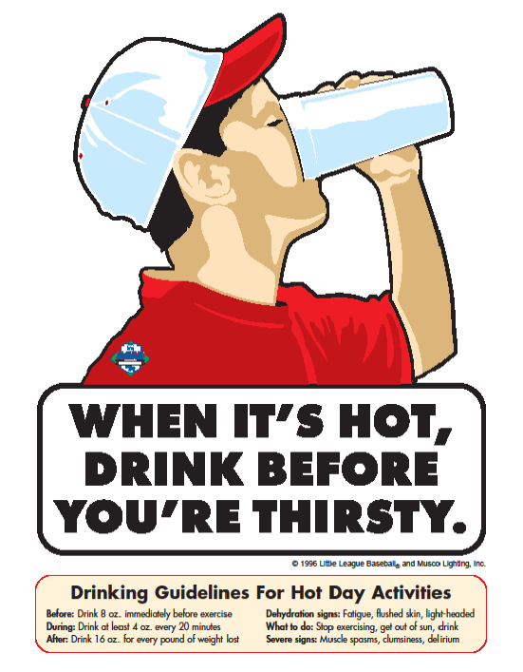
- Take frequent breaks when heat and humidity is high. Wear light-weight, light-colored and loose fit clothing.
- Don't hesitate to take a player out of the game or practice if they show any of the heat illness symptoms. If a player is thirsty, they are already experiencing dehydration. Allow players time to recover until you are convinced they are well hydrated and rested.
- If a player begins to show signs of more severe dehydration, bring them to a cool place, and place a cold, wet cloth on their forehead and neck. If a player is unresponsive or unable to consume liquids, they must receive immediate medical attention. Call E-911 and DO NOT ADMINISTER MEDICATION. Be aware of signs of shock while waiting for medical help to arrive.

OTHER NON-EMERGENCY ACCIDENTS/INJURIES
Injuries to arms and legs, especially ankles and knees, are common among players.
When an injury occurs follow the following PRICE system protocol:
- Protect the injured area. First, stop playing. Remove the player from the field and avoid putting any weight on the injury.
- Rest and allow the injury time to heal. Don't let the players desire to play again override the need for rest. The player's body must have time to heal. If they injure the same area again, it can turn out to be a more severe injury and recovery time is often longer than the first time.
- Ice the area for 20 minutes every two - three hours while awake. Protect the skin with a thin towel or t- shirt. An ice pack with crushed ice or a bag of frozen peas is optimal. If the skin becomes red, raised, and blotchy — immediately remove the ice and allow the area to warm.
- Compression is used to minimize swelling after the ice pack is removed. Most common compression wraps are the elastic or ace bandage. Use a wrap that is appropriate for the body part affected.
- Elevate the injured area above the heart to help slow and reduce swelling. Use a pillow or blanket to help with elevation of the injury.
The player should start the healing process in a day or two. Seek medical attention if pain or swelling does not decrease after 48 hours. Once the swelling subsides, the player can start some gentle stretching, working up to the full range of motion of the injured joint or muscle. Use caution when stretching; do not force a stretch and stop the player from stretching immediately if there is pain.

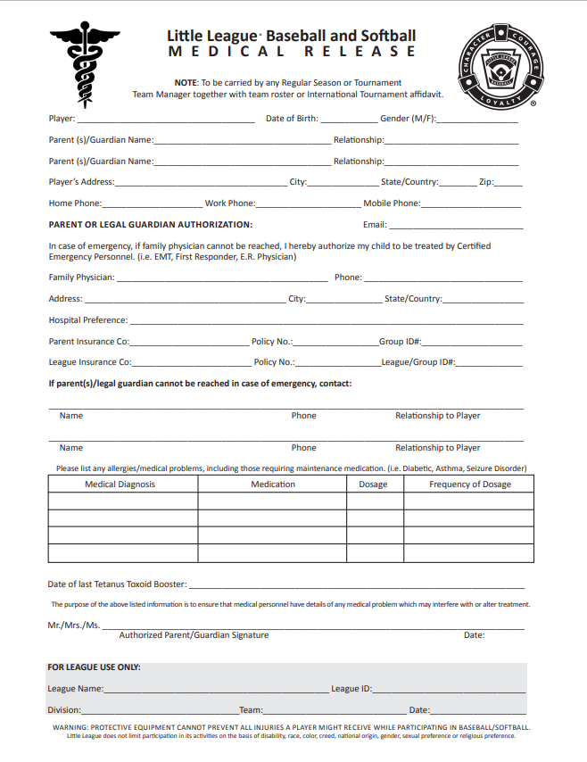
Little League® Baseball & Softball
CLAIM FORM INSTRUCTIONS

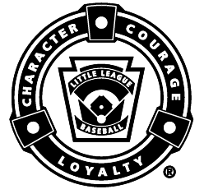

WARNING — It is important that parents/guardians and players note that: Protective equipment cannot prevent all injuries a player might receive while participating in baseball/softball.
To expedite league personnel’s reporting of injuries, we have prepared guidelines to use as a checklist in completing reports. It will save time -- and speed your payment of claims.
The National Union Fire Insurance Company of Pittsburgh, Pa. (NUFIC) Accident Master Policy acquired through Little League® contains an “Excess Coverage Provision” whereby all personal and/or group insurance shall be used first.
The Accident Claim Form must be fully completed, including a Social Security Number, for processing.
To help explain insurance coverage to parents/guardians refer to What Parents Should Know on the internet that should be reproduced on your league’s letterhead and distributed to parents/guardians of all participants at registration time.
If injuries occur, initially it is necessary to determine whether claimant’s parents/guardians or the claimant has other insurance such as group, employer, Blue Cross and Blue Shield, etc., which pays benefits. (This information should be obtained at the time of registration prior to tryouts.) If such coverage is provided, the claim must be filed first with the primary company under which the parent/guardian or claimant is insured.
When filing a claim, all medical costs should be fully itemized and forwarded to Little League International. If no other insurance is in effect, a letter from the parent/guardian or claimant’s employer explaining the lack of group or employer insurance should accompany the claim form.
The NUFIC Accident Policy is acquired by leagues, not parents, and provides comprehensive coverage at an affordable cost. Accident coverage is underwritten by National Union Fire Insurance Company of Pittsburgh, a Pennsylvania Insurance company, with its principal place of business at 175 Water Street, 18th Floor, New York, NY 10038. It is currently authorized to transact business in all states and the District of Columbia. NAIC Number 19445.This is a brief description of the coverage available under the policy. The policy will contain limitations, exclusions, and termination provisions. Full details of the coverage are contained in the Policy. If there are any conflicts between this document and the Policy, the Policy shall govern.
The current insurance rates would not be possible without your help in stressing safety programs at the local level. The ASAP manual, League Safety Officer Program Kit, is recommended for use by your Safety Officer.

TREATMENT OF DENTAL INJURIES
Deferred Dental Treatment for claims or injuries occurring in 2002 and beyond: If the insured incurs injury to sound, natural teeth and necessary treatment requires that dental treatment for that injury must be postponed to a date more than 52 weeks after the date of the injury due to, but not limited to, the physiological changes occurring to an insured who is a growing child, we will pay the lesser of the maximum benefit of $1,500.00 or the reasonable expense incurred for the deferred dental treatment. Reasonable expenses incurred for deferred dental treatment are only covered if they are incurred on or before the insured's 23rd birthday. Reasonable Expenses incurred for deferred root canal therapy are only covered if they are incurred within 104 weeks after the date the Injury is sustained.
CHECKLIST FOR PREPARING CLAIM FORM
- Print or type all information.
- Complete all portions of the claim form before mailing to our office.
- Be sure to include league name and league ID number.

PART I - CLAIMANT, OR PARENT/GUARDIAN(S), IF CLAIMANT IS A MINOR

- The adult claimant or parent(s)/guardians(s) must sign this section, if the claimant is a minor.
- Give the name and address of the injured person, along with the name and address of the
parent(s)/guardian(s), if claimant is a minor.
- Fill out all sections, including check marks in the appropriate boxes for all categories. Do not leave any
section blank. This will cause a delay in processing your claim and a copy of the claim form will be
returned to you for completion.
- It is mandatory to forward information on other insurance. Without that information there will be a delay in
processing your claim. If no insurance, written verification from each parent/spouse employer must be
submitted.
- Be certain all necessary papers are attached to the claim form. (See instruction 3.) Only itemized bills are
acceptable.
- On dental claims, it is necessary to submit charges to the major medical and dental insurance company of
the claimant, or parent(s)/guardian(s) if claimant is a minor. “Accident-related treatment to whole, sound,
natural teeth as a direct and independent result of an accident” must be stated on the form and bills. Please
forward a copy of the insurance company’s response to Little League International. Include the claimant’s
name, league ID, and year of the injury on the form.
PART II - LEAGUE STATEMENT

- This section must be filled out, signed and dated by the league official
- Fill out all sections, including check marks in the appropriate boxes for all categories. Do not leave any
section blank. This will cause a delay in processing your claim and a copy of the claim form will be
returned to you for completion.

IMPORTANT: Notification of a claim should be filed with Little League International within 20 days of the incident for the current season.

Access the claim form online:
https://www.littleleague.org/downloads/accident-claim-form/

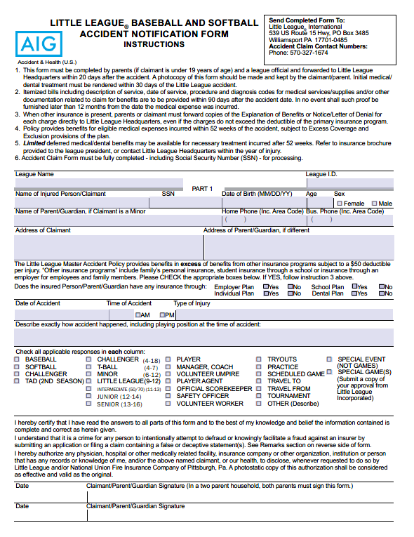

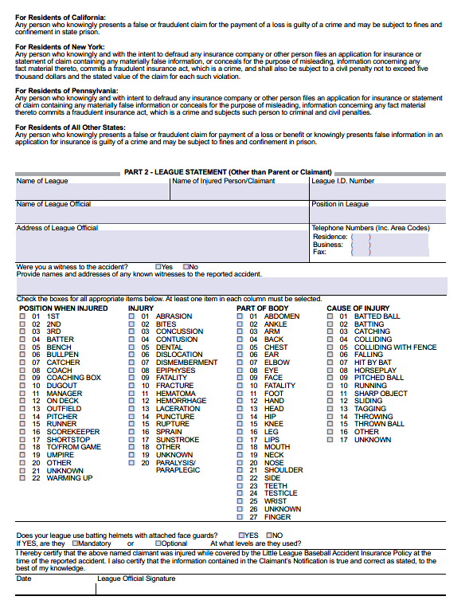

Access the injury form online:
https://www.littleleague.org/downloads/incident-injury-tracking-form/

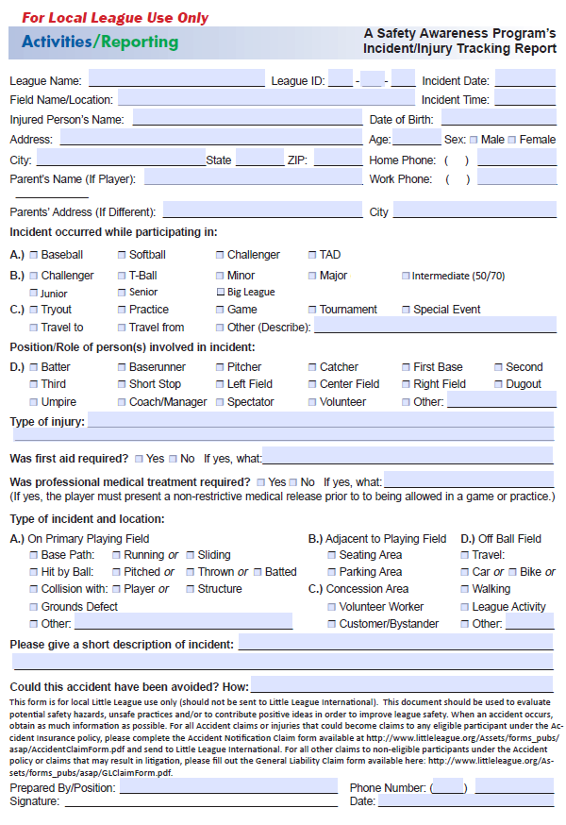

Access the Liability form online:
https://www.littleleague.org/downloads/general-liability-claim-form/
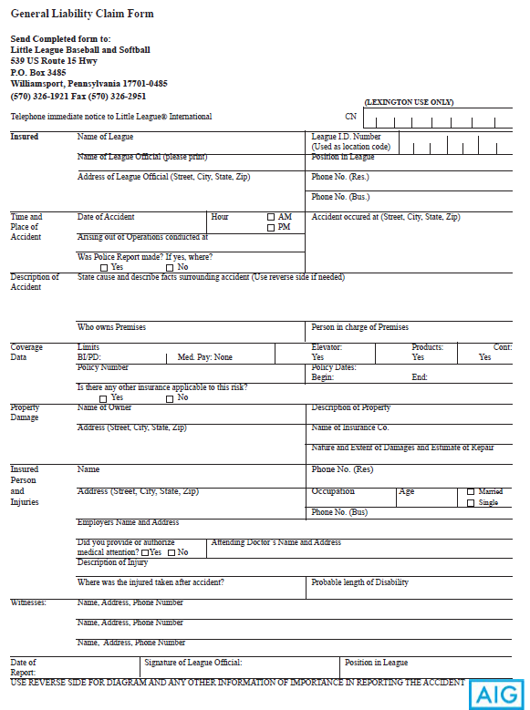

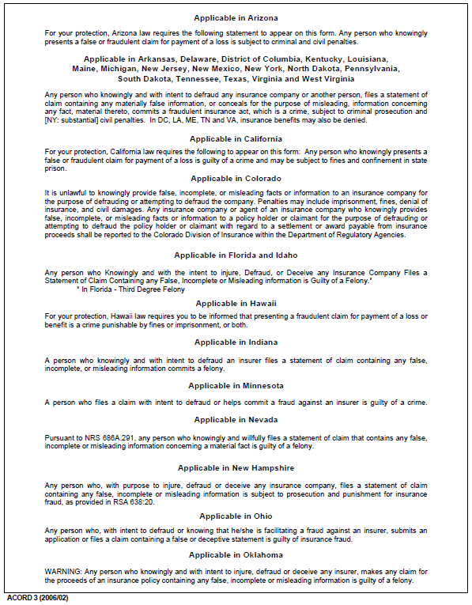

Snack Bar Management and Safety Procedures
Every team Manager within DNLL is responsible to provide Snack Bar coverage on designated days by enlisting the help of parent volunteers.
The DNLL Snack Bar, located behind the backstop at Moulton Field, is a significant revenue generator for DNLL. Maximizing snack bar revenue enables DNLL to charge the lowest registration fee within District 15.
The DNLL Snack Bar is managed by the DNLL Snack Bar Manager and serves basic concessions: hot/cold drinks, candy, popcorn, ice cream, slush, pretzels, hot dogs and pizza.
The Snack Bar schedule is produced the Snack Bar Manager, posted inside the Snack Bar and the DNLL web site.
Prior to the start of each season DNLL Snack Bar Manager inspects concession equipment and recommends items needing replacement to the Board of Directors. Recent equipment replacements include a hot dog roller, popcorn machine, slush machine and refrigerator.
Any Snack Bar Volunteer that identifies defective equipment should contact the Snack Bar Manager for replacement.
Snack Bar Volunteers should check the DNLL website www.danversnats.com on inclement weather days before reporting for duty.
General rule of thumb: if the fields are open, then so is the snack bar.
The suggested "Snack Bar Team" consists of two adults per shift, and the recommended shift is two to three hours long.
Snack Bar Volunteers should use caution when enlisting younger helpers, as the hot dog roller is hot when in use and hot beverages are often being served.
Please adhere to the following safety guidelines to ensure both the safety of our patrons and volunteers working the snack bar:
- All snack bar volunteers must frequently wash hands. (See Attachment # 4: "Volunteers Must Wash Hands" poster displayed in snack bar.)
- Proper food handling procedures must be followed at all times.
- Gloves are provided and MUST be worn by all who handle food.
- All snack bar equipment shall be stored safely and checked regularly.
- All chemicals will be stored in accordance to the local health codes.
- Two adults will be present at closing every night
- A fully stocked First-Aid kit and ice packs will be located in the snack bar.
ATTACHMENT 4:

VOLUNTEERS MUST WASH HANDS!
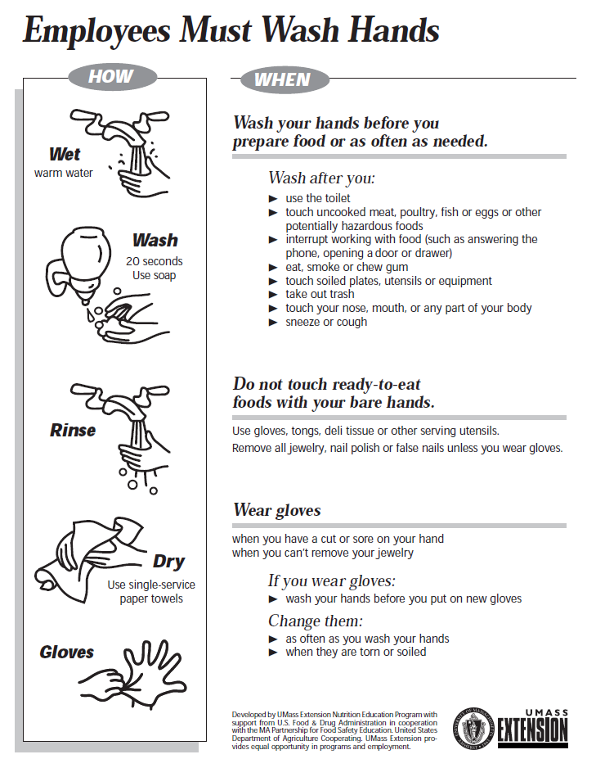

Equipment Inspection & Replacement Policy
DNLL maintains a dedicated Board of Director's position (Equipment Chairperson) to ensure that all youth baseball equipment meets little league safety standards.
All DNLL participants are provided with necessary equipment for safe play. All batters and catchers are required to wear protective equipment (including but not limited to helmets, catchers helmet/mask, dangling throat protector, shin pads, chest protector and protective cup) for both practices and games - including warm-ups. Managers and Coaches are reminded that they are not allowed to catch pitchers (Little League Rule Handbook, rule 3.09).
Player base coaches are required to wear a protective helmet.
DNLL conducts a postseason and preseason equipment inspection each Fall and Spring.
The postseason equipment inspection was conducted in October 2020 at Tapley Park by DNLL President, DNLL Equipment Chairperson and District 15 Safety Officer.
During the inspection the batting cage net and soft toss nets were removed and stored away in the job box. The equipment shed was organized. Defective helmets, catcher equipment and bats were discarded in the dumpster. Bases were checked to make sure they were in good condition. Inventory was taken for the purpose of recommending new equipment purchases to the Board for the upcoming season.
A second equipment inspection will be coordinated by DNLL Equipment Chairperson in March/April 2021. During this inspection new equipment bags are prepared for distribution with team first aid kits, catcher equipment, batting helmets, batting tees, baseball bats, scorebooks and baseballs.
General Equipment Inspection Guidelines
- All helmets are inspected and any cracked/broken helmets or helmets that are missing padding are discarded in the dumpster at Tapley Park.
- All catchers equipment (helmets, masks, dangling throat protectors, shin guards, chest protectors, catchers mitts) are inspected and any defective equipment is discarded in the dumpster at Tapley Park.
- All baseball bats, whether owned by the league or owned by the player, are inspected before opening day. All bats are checked for wear/tear or any defects and are then checked against the Little League Baseball Standard Approved Bat list.
The list is ever changing and an updated version can be accessed from the Little League International web site. Parents are strongly encouraged to check this list before any baseball bat purchase.) When a bat is verified against the bat list, a bat sticker is applied to the bat. Authorized baseball bat checks can be conducted by the DNLL President, DNLL Safety Officer, DNLL Equipment Chairperson or the applicable Division Directors (Major, AAA or AA).

It is the responsibility of all Managers and Coaches to ensure that all baseball bats used in games and practices are stickered and dangling throat protectors are worn by the catcher. Moreover, managers are required to ensure that all equipment is in good working order at all times and any equipment that becomes defective during the season is replaced.

DNLL Pre-Game/Practice Field and Equipment Inspection Form
All Managers, Coaches and Umpires share the responsibility of assessing the field and equipment before games and practices. The form below can be utilized as a standard checklist of items to be mindful of.
Field Condition |  |  | Player Equipment
Repair Needed Yes No |  |  | Repair Needed Yes * No
Outfield Fence  Backstop  Dugouts  Bases  Home Plate  Mound  Infield Grass  Outfield Grass  Coaches Box  Safety Equipment  First-Aid Kit  Medical Forms  Safety Manual  Ice Packs  Batting Screens |  |  | Helmets  Catchers Gear  Stickered Bats  Gloves  Athletic Cups  Dangling Throat  Protector
 |  |  | Spectator Area
 |  |  | Issue Yes No
Bleachers
No Smoking
Parking Area

*-If Player Equipment is defective, please discard in the dumpster at Highlands School or Tapley Park and notify DNLL Safety Officer and DNLL Equipment Chairperson.
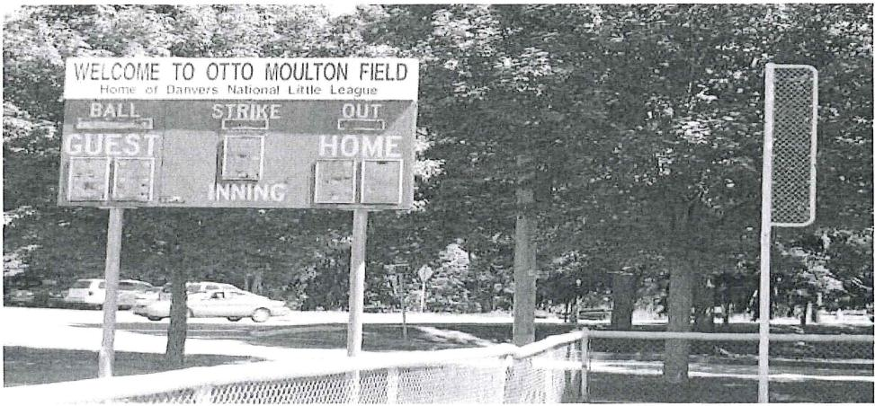

SPECIFIC BALLFIELD QUESTIONS
•Please list all fields by name.
ASAP - A Safety Awareness Program | Field Name | Moulton | Phinney | John George I | John George II | Highlands Front | Highlands Back | Highlands New
Please answer the following questions for each field: | Field Number | 1 | 2 | 3 | 4 | 5 | 6 | 7 | 8 | 9 | 10 | 11 | 12 | 13 | 14 | 15
GENERAL INVENTORY | (For the following questions, if the answer is "No" please leave the space blank.)
1.How many cars can park in designated parking areas? | None
 | 1-50 |  |  | x | x | x | x | x
 | 51-100 | x | x
 | 101 or more
2.How many people can your bleachers seat? | None/NA |  |  |  |  | x | x | x
 | 1-100 |  |  | x | x
 | 101-300 | x | x
 | 301-500
 | 501 or more
3.What material is used for bleachers? | Wood
 | Metal | x | x | x | x
 | Other
4.Metal bleachers: Ground wire attached to ground rod? | Yes | x | x | x | x
5.Wood bleachers: Are inspected annually for safety? | Yes
6.Is a safety railing at the top/back of bleachers? | Yes | x | x | x | x
7.Is a handrail up the sides of bleachers? | Yes | x | x | x | x
8.Is telephone service available? | Permanent | x | x
 | Cellular | x | x | x | x | x | x | x
9.Is a public address system available? | Permanent
 | Portable | x | x | x | x | x | x | x
10.Is there a pressbox? | Yes | x
11.Is there a scoreboard? | Yes | x
12.Adequate bathroom facilities available? | Yes | x | x | x | x | x | x | x
13.Permanent concession stands? | Yes | x | x
14.Mobile concession stands? | Yes

FIELD | Field Number | 1 | 2 | 3 | 4 | 5 | 6 | 7 | 8 | 9 | 10 | 11 | 12 | 13 | 14 | 15
15.Is field completely fenced? | Yes | x | x
16.What type of fencing material is used? | Chainlink | x | x
 | Wood
 | Wire
17.What base path material is used? | Sand, clay, soil mix | x | x | x | x |  | x
 | Ground burnt brick
 | Other: |  |  |  |  | x |  | x
18.What is used to mark baseline? | Non-caustic lime | x | x | x | x
 | Spray paint |  |  |  |  | x | x | x
 | Commerc'l marking
19.Is your the infield surface grass? | Yes | x | x |  |  | x | x | x
20.Does field have conventional dirt pitching mound? | Yes | x | x | x | x | x | x | x
21.Does field have a temporary pitching mound? | Yes
22.Are there foul poles? | Yes | x | x
23.Backstop behind home plate? | Yes | x | x | x | x | x | x | x
PERFORMANCE AND PLAYER SAFETY | Field Number | 1 | 2 | 3 | 4 | 5 | 6 | 7 | 8 | 9 | 10 | 11 | 12 | 13 | 14 | 15
24.Is there an outfield warning track? | Yes
24.a. If yes, what width is warning track? Please specify: | (Width in feet)
25.Batter's eye (screen/covering) at center field? | Yes
26.Pitcher's eye (screen/covering) behind home plate? | Yes
27.Are there protective fences in front of the dugouts? | Yes | x | x | x | x
28.Is there a protected, on-deck batter's area? (On-deck areas have been eliminated for ages 12 and below.) | Yes
29.Do you have fenced, limited access bull pens? | Yes | x | x | x | x
30.Is a first aid kit provided per field? | Yes | x | x | x | x | x | x | x
31.Do bleachers have spectator foul ball protection? | Overhead screens
 | Fencing behind | x | x | x | x
32.Do your bases disengage from their anchors? (Mandatory since 2008) | Yes | x | x | x | x | x | x | x
33.Is the field lighted? | Yes | x
34.Are light levels at/above Little League standards?  (50 footcandles infield/30 footcandles outfield) | Yes | x
 | Don't know
35.What type of poles are used?  (Wood poles have not been allowed by Little League  for new construction of lighting since 1994) | Wood*
 | Steel | x
 | Concrete
36.Is electrical wiring to each pole underground? | Yes | x
37.Ground wires connected to ground rods on each pole? | Yes | x
38.Which fields were tested/inspected in the last two years?  Please indicate month/year testing was done (example: 3/10). | Electrical System | x
 | Light Levels | x
39.Fields tested/inspected by qualified technician? | Electrical System | x
 | Light Levels | x

FACILITY MANAGEMENT | Field Number | 1 | 2 | 3 | 4 | 5 | 6 | 7 | 8 | 9 | 10 | 11 | 12 | 13 | 14 | 15
40. Which fields have the following limitations:
a.Amount of time for practice? | Yes | x | x | x | x | x | x | x
b.Number of teams or games? | Yes | x | x | x | x | x | x | x
c.Scheduling and/or timing? | Yes | x | x | x | x | x | x | x
41. Who owns the field? | Municipal | x | x | x | x | x | x | x
 | School
 | League
42. Who is responsible for operational energy costs? | Municipal
 | School
 | League | x | x | x | x | x | x | x
43. Who is responsible for operational maintenance? | Municipal
 | School
 | League | x | x | x | x | x | x | x
44. Who is responsible for puchasing improvements  for the field - ie bleachers, fences, lights? | Municipal
 | School
 | League | x | x | x | x | x | x | x
 | Other
45. What divisions of baseball play on each field? | T-Ball & Minor | x | x | x | x | x | x | x
 | Major | x | x
 | Jr., Sr. & Big
 | Challenger | x | x
 | 50 — 70
46. What divisions of softball play on each field? | T-Ball & Minor
 | Major
 | Jr., Sr. & Big
 | Challenger
47. Do you plan to host tournaments on this field? | Yes | x | x

FIELD DIMENSION DATA
Please complete for each field. Use additional space if necessary.
Field No. | Height  of  outfield  fence | Distance from home plate to: |  |  |  | Foul territory distance from:
 |  | Outfield fence |  |  |  | Left field line to fence at: |  |  | Right field line to fence at:
 |  | Left | Center | Right | Back  stop | Home | 3rd | Outfield foul pole | Home | 1st | Outfield foul pole
1 | 48" | 175' | 185' | 185' | 14' | 9' | 4' | 3' | 9' | 6' | 3'
2 | 60" | 200' | 200' | 200' | 15' | 15' | 6' | 4' | 15' | 6' | 4'
3 | N/A | N/A | N/A | N/A | 15' | N/A | N/A | N/A | N/A | N/A | N/A
4 | N/A | N/A | N/A | N/A | 15' | N/A | N/A | N/A | N/A | N/A | N/A
5 | N/A | N/A | N/A | N/A | 15' | N/A | N/A | N/A | N/A | N/A | N/A
6 | N/A | N/A | N/A | N/A | 15' | N/A | N/A | N/A | N/A | N/A | N/A
7 | N/A | N/A | N/A | N/A | 15' | N/A | N/A | N/A | N/A | N/A | N/A
8
9
10
11
12
13
14
15

Return completed survey with safety program registration and supporting materials to:
Mailing address:
Little League International
PO Box 3485
Williamsport, PA 17701
Shipping address:
Little League International
539 US Route 15 Hwy.
South Williamsport, PA 17702
Leagues completing their facility survey via form should include it with safety plan submission.

Inclement Weather
Lightning is the most dangerous and frequently encountered weather hazard that people experience each year.
What to Look For
While the most obvious sign of lightning is seeing it, there are other signs. Look for signs of a thunderstorm including dark, anvil shaped clouds, and a change in temperature.
Thunder/Lightning Action Plan
- Always check the weather before a game or practice. Utilize your smart phone at the field. Same-day forecasts can accurately describe the weather to expect.
- If you notice lightning or hear thunder in the distance, verbally call it out. If you see or hear it, it's close enough to be dangerous.
- If lightning is sighted, STOP game or practice immediately.
- Move away from metal fencing and light fixtures. Get everyone off the field, out of the dug outs, and off any bleachers. Do not hold any metal bats.
- Make sure everyone gets inside of a vehicle to wait out the lightning.
- If the game isn't called due to inclement weather a DNLL Official, Umpire or Manager/Coach will give the all-clear 30 minutes after the last THUNDER was heard.
Game Postponement/Cancelation Information
In the event of Inclement Weather, please visit the DNLL website www.danversnats.com
Click on "Postponement & Makeup's" on the DNLL homepage (top right corner).

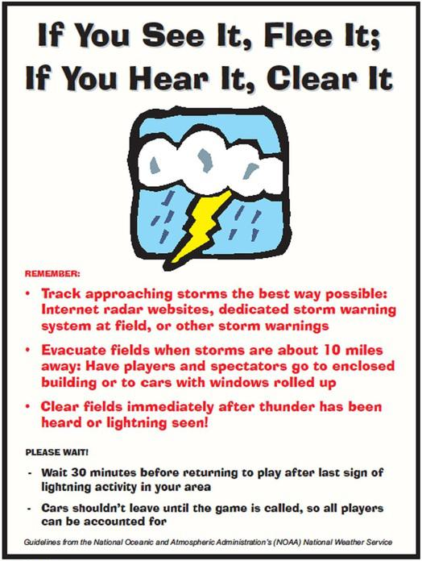

Access ths online: https://www.littleleague.org/downloads/parents-guide-child-protection/

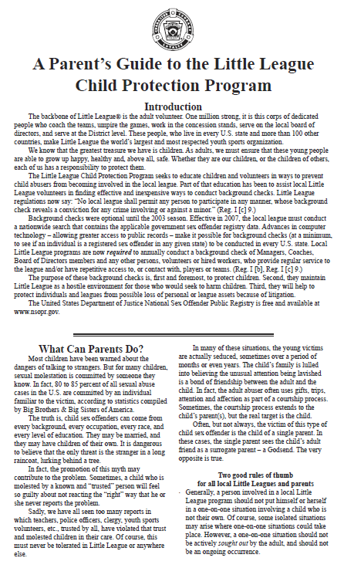

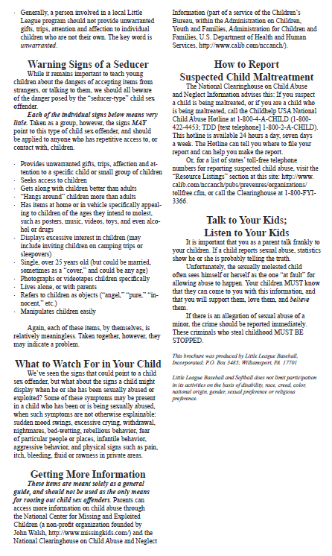

DNLL Parking Policy
Parking at Tapley Park
Parking at Tapley Park can be extremely tight during the baseball season, particularly on weekends.
Please park your vehicle in a designated parking spot at Tapley.
If all designated parking spots are utilized, please park your vehicle in the satellite parking lot abutting the bike path across Pine Street.
Use the crosswalk to access Tapley Park.
Please note that parking at 142 Pine Street (Scrubbles Laundromat and Petes-A-Place Restaurant) is prohibited, and may result in your vehicle being towed.
Parking at Highlands School
Parking for games at Highlands School can also be tight.
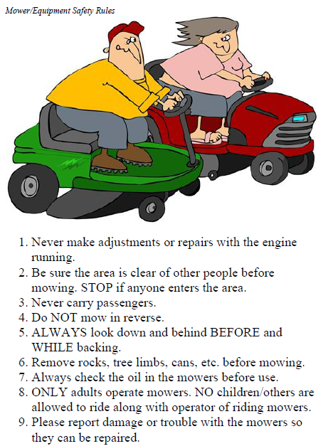
Please park your vehicle in a designated parking spot at the School, or a designated area along Hobart Street.
Parking at First Church of Danvers at 41 Centre Street is prohibited, and may result in your vehicle being towed.
Tractor Safety
During the 2013 season, DNLL purchased a motorized tractor for the purpose of grounds keeping and maintenance of Moulton and Phinney Field.
Authorized users of the vehicle must have a valid driver's license and must complete a tractor training session. Moreover, players are prohibited from operating or riding on the tractor at any time. NO EXCEPTIONS.

